Sulfuryl fluoride fumigation methodology
Version 1.1
© Commonwealth of Australia 2018
Ownership of intellectual property rights
Unless otherwise noted, copyright (and any other intellectual property rights, if any) in this publication is owned by the Commonwealth of Australia (referred to as the Commonwealth).
Creative Commons licence
All material in this publication is licensed under a Creative Commons Attribution 4.0 International Licence except content supplied by third parties, logos and the Commonwealth Coat of Arms.
Inquiries about the licence and any use of this document should be emailed to copyright@agriculture.gov.au.
Cataloguing data
This publication (and any material sourced from it) should be attributed as: Department of Agriculture and Water Resources, 2018, Sulfuryl fluoride fumigation methodology, Canberra, November. CC BY 4.0.
This publication is available at agriculture.gov.au/publications.
Department of Agriculture and Water Resources
Postal address GPO Box 858 Canberra ACT 2601
Telephone 1800 900 090
Web agriculture.gov.au
The Australian Government acting through the Department of Agriculture and Water Resources has exercised due care and skill in preparing and compiling the information and data in this publication. Notwithstanding, the Department of Agriculture and Water Resources, its employees and advisers disclaim all liability, including liability for negligence and for any loss, damage, injury, expense or cost incurred by any person as a result of accessing, using or relying upon any of the information or data in this publication to the maximum extent permitted by law.

Purpose
This methodology sets out the minimum requirements for treatment providers performing sulfuryl fluoride fumigations on commodities and/or associated packaging suited to such treatments for Quarantine and Pre-shipment (QPS) purposes. This methodology is the basis for compliance auditing of treatment providers to monitor their performance of effective QPS treatments with sulfuryl fluoride.

Scope
This document applies to commercial and government treatment providers performing QPS sulfuryl fluoride fumigation treatments for countries that have adopted a specific sulfuryl fluoride treatment schedule.
This document is not intended to specifically cover the performance of sulfuryl fluoride fumigation treatments under ISPM 15. However, the basic principles, requirements and recommendations described in this document and the associated guideline are still generally applicable.
Even though the basic principles and requirements would be relevant, this document is not intended to specifically cover fumigations of vessels (whether it is the vessel itself or its cargo), silos or other storage facilities, buildings or other fumigations that are not done in the types of enclosure described herein and not related to import or export.

General
Best fumigation practice is the result of a practical combination of all procedures required during a fumigation treatment to ensure that:
- the people conducting the fumigation remain safe and are not harmed
- all people in the area around the fumigation treatment area remain safe and are not harmed
- the environment is not harmed
- all life stages of all target pests are killed
- the commodity, or product, or equipment being treated inside the fumigation enclosure is not damaged in any way.
Fumigation treatment providers registering to perform official treatments in accordance with these requirements must have the equipment, facilities, competent licenced fumigators and management and administrative procedures necessary to ensure that all relevant treatments comply with these requirements.
Importing countries have the right to impose more stringent treatment conditions to address their individual biosecurity risks. If that is the case, those additional conditions take precedence over these requirements and must be complied with to the satisfaction of the relevant authority of the importing country.
Countries receiving treatment certification through this system expect the treatment has been undertaken in accordance with this methodology. Treatment providers found to be wilfully and consistently not complying with the requirements of this methodology and/or other specified treatment conditions will have their registration status changed to ‘unacceptable’ until such time as they can demonstrate satisfactory compliance.
Performing fumigations in accordance with these requirements will reduce the use of sulfuryl fluoride by minimising the need for re-treatment of consignments due to ineffective fumigations caused by poor fumigation practices.

How to use this document
Some of the requirements in this methodology only apply in certain circumstances, generally related to the type of enclosure used. It is important for the fumigators and compliance auditors to understand the purpose of the requirements and the outcomes they are intended to achieve and the particular circumstances in which they apply.

Contents
Purpose iii
Scope iii
General iii
How to use this document iv
1 Prior to fumigation 2
1.1 Target of the fumigation 2
1.2 Consignment suitability 2
1.3 Free airspace 2
1.4 Timber thickness and spacing 2
1.5 Impervious wrappings, coatings and surfaces 2
1.6 Site suitability 3
2 Safety 3
2.1 Risk assessment 3
2.2 Risk area 3
2.3 Personal protective equipment (PPE) 4
3 Fumigation enclosures 4
3.1 Gas-tightness 4
3.2 Sheeted enclosures 4
3.3 Un-sheeted shipping containers 5
3.4 Fumigation chambers 5
3.5 Pressure testing 6
4 Preparing the fumigation enclosure 6
4.1 Concentration sampling tubes 6
4.2 Concentration sampling tube placement 6
4.3 Fumigant supply pipes 8
4.4 Fans 8
4.5 Temperature 8
5 Calculating the dose 9
5.1 Dose rate 9
5.2 Dose calculation 9
5.3 Enclosure volume 9
5.4 Rounding 9
6 Applying the dose 9
6.1 Releasing the fumigant 9
6.2 Checking for leaks 10
6.3 Circulating the fumigant 10
7 Monitoring fumigant concentration levels 10
7.1 Concentration measuring instruments 10
7.2 Monitoring frequency 11
7.3 Start time of the fumigation 11
7.4 Minimum concentration levels 12
7.5 End of the exposure period 12
8 Topping-up to compensate for low concentrations 12
8.1 Topping-up 12
8.2 Calculating the top-up amount 13
8.3 Restrictions on topping-up 13
8.4 Topping-up during the exposure period 13
8.5 Topping-up at the end of the exposure period 13
9 Ventilating the enclosure 14
9.1 Threshold limit value – time weighted average (TLV-TWA) 14
9.2 Releasing the fumigant from the enclosure 14
9.3 Releasing the consignment from the fumigator’s control 14
10 Documentation 15
10.1 Record of Fumigation 15
10.2 Fumigation treatment certificate 16
Appendix 1a: Example record of fumigation 18
Appendix 1b: Example record of fumigation (3rd Party Approved System) 19
Appendix 2a: Example fumigation certificate 20
Appendix 2b: Example fumigation certificate (3rd Party Approved System) 21
Appendix 3: Sulfuryl fluoride monitoring tables 22
Glossary 24

Figures
Figure 1 Concentration sampling tube positions within a single enclosure 6
Figure 2 Concentration sampling tube positions within two containers under a single enclosure 7
Figure 3 Concentration sampling tube positions within three containers under a single enclosure 7
Figure 4 Sulfuryl Fluoride minimum concentration requirement and top-up calculation guide 13
Figure 5 Sulfuryl fluoride monitoring table for a 24 hour exposure period 22
Figure 6 Sulfuryl fluoride monitoring table for a 12 hour exposure period 23

1 Prior to fumigation

Target of the fumigation
1.1.1 The fumigator must know the correct treatment schedule to be applied for the pest/commodity/country combination.
1.1.2 The fumigator must have the relevant regulatory approval and training.
1.1.3 The fumigator must have the appropriate resources to undertake the fumigation in compliance with this methodology.
1.1.5 The fumigator must know what the target of the fumigation is.
1.1.6 The target of the fumigation must be recorded on the fumigation documentation.

Consignment suitability
1.2.1 The fumigator must determine if the target of the fumigation is suitable for fumigation with sulfuryl fluoride.
1.2.2 If the target of the fumigation is unsuitable for fumigation with sulfuryl fluoride, remedial action must be taken to ensure it is suitable or an alternative, acceptable treatment must be conducted.

Free airspace
1.3.1 There must be sufficient free space throughout the enclosure to allow the fumigant to freely circulate around the target of the fumigation.
1.3.2 There must be sufficient free airspace to permit the positioning of sampling tubes in appropriate locations within the enclosure. See 4.1 Concentration sampling tubes.

Timber thickness and spacing
1.4.1 Untreated timber products must have at least one full physical dimension which is less than 200mm thick.
1.4.2 Timber and timber product fumigations must be conducted before any surface coatings are applied, unless all parts of the timber or timber product have at least one uncoated surface with a maximum thickness of 100mm from the uncoated surface.
1.4.3 Where timber is the target of the fumigation, it must be separated by a minimum of 5mm of airspace every 200mm. This separation can be horizontal or vertical.

Impervious wrappings, coatings and surfaces
1.5.1 Where penetration into the target of the fumigation is required, the target of the fumigation must not be coated in materials that will prevent sulfuryl fluoride from penetrating into the target of fumigation such as lacquers, paints, waxes, natural oils, veneers or plastic wraps.
1.5.2 Where penetration into the target of the fumigation is required, impervious wrappings must be removed, opened or slashed prior to fumigation in such a way to allow sulfuryl fluoride to come into contact with and, if needed, penetrate into the target of the fumigation.

Site suitability
1.61 The fumigation site must:
- have adequate space to establish a risk area around the enclosure
- allow for safe ventilation
- be flat and even
- be well ventilated
- have power available, either mains or generator.

Safety

Risk assessment
2.1.1 Before commencing any fumigation a risk assessment must be carried out to determine if any hazards are present and evaluate the potential consequences to:
- fumigation personnel
- people in the vicinity
- occupants of surrounding buildings.
2.1.2 Appropriate control measures must be in place to address the hazards identified.
2.1.3 The risks must be reviewed as needed to respond to changing circumstances and the control measures must be adjusted accordingly.
2.1.4 The designated fumigator-in-charge is responsible for the safe conduct of the fumigation.

Risk area
2.2.1 A risk area must be established around the perimeter of the enclosure warning people the fumigation is taking place.
2.2.2 The risk area must be demarcated by a physical barrier for the duration of the fumigation.
2.2.3 The size of the risk area should be set according to the risk but must not be less than:
- 3 metres from the enclosure outdoors
- 6 metres from the enclosure inside a building or structure.
2.2.4 For fumigations in a chamber, see 3.4 Fumigation chambers, a risk area is not required after the fumigant has been applied provided that the chamber is locked from the time the fumigant is ready to be applied until the fumigant has been ventilated and the concentration verified at or below the TLV–TWA. See 9.1 Threshold limit value—time weighted average (TLV–TWA).
A risk area must still be established according to requirement 2.2.3 and Personal Protective Equipment (PPE) must be worn while injecting the fumigant into the chamber to protect the fumigator and others against accidental exposure to the fumigant from a failure in the supply system.
2.2.5 Warning signs must be placed around the enclosure. They must:
- be large enough to be visible from a reasonable distance
- be visible from all angles of approach
- display easily understood symbols indicating danger and/or toxic gas is in use
- provide 24 hour contact details of the fumigator
- be in a language or languages appropriate to the location.
2.2.6 The risk area, with the exception of chamber fumigations, must be in force from the time immediately prior to connection of the sulfuryl fluoride supply to the supply system up until the gas concentration in the risk area and the enclosure is verified at or below the TLV–TWA.
2.2.7 Anyone entering the risk area while it is in force must be wearing appropriate PPE at all times.

Personal protective equipment (PPE)
2.3.1 Suitable respiratory protection must be worn at all times inside the risk area while it is in force.
2.3.2 Respiratory protection must be worn at all times when inside the buffer zone during ventilation. See 9 Ventilating the enclosure.
2.3.3 Self–contained breathing apparatus must be:
- operated in accordance with the manufacturer’s instructions
- used only by properly trained personnel
- maintained in good working order
- refilled from a safe source.

Fumigation enclosures

Gas-tightness
3.1.1 All fumigation enclosures must be sufficiently gas-tight to retain the fumigant for the duration of the exposure period and maintain the concentrations at or above the requirements.

Sheeted enclosures
3.2.1 The surface on which the sheeted enclosure will be created must be:
- impervious to sulfuryl fluoride or covered with a gas-proof sheet if the surface is not impervious
- free of debris that might prevent a gas-tight seal or damage the sheet
- free of cracks and drains or other openings.
3.2.2 The fumigation sheets must be impervious to sulfuryl fluoride. They must be able to retain the required concentration for the duration of the fumigation without needing to add additional sulfuryl fluoride due to permeation through the sheet.
3.2.3 A gas-tight seal must be created between the fumigation surface and the sheet.
3.2.4 If one or more shipping containers are fumigated in a sheeted enclosure at least one door of each container must be open during the fumigation.

Un-sheeted shipping containers
3.3.1 A shipping container can be used as a fumigation enclosure if it can be sealed to make it adequately gas-tight. The fumigator must;
- check the container for any visible holes or damage that would make it unsuitable
- seal the air vents
- install sampling tubes— see 4.1 Concentration sampling tubes
- install a fan—if there is insufficient space, the container must be fumigated as a sheeted enclosure
- arrange the tubes and leads so they exit the container where the doors meet at the base of the container
- create a barrier to reduce air flow under the container when the container is situated on the ground.
3.3.2 The sulfuryl fluoride must be applied through the door seals and the supply pipe must be removed after the process is complete. This is easiest to do through the door seals where they meet at the top of the container.
3.3.3 Where a false door is fitted to create a gas tight seal, the supply pipe, sampling tubes and power leads must pass through the false door.
3.3.4 Where an un-sheeted shipping container fumigation is conducted on a skeletal trailer, leak checks must be conducted on the underside of the container. A barrier to reduce airflow under the container is not required.
3.3.5 Soft top containers must be sheeted.
3.3.6 Shipping containers under gas must not be moved until they have been ventilated.
3.3.7 If the target of the fumigation includes the exterior of the container, for example Giant African Snail treatments, the container/s must be enclosed under gas–proof sheets.

Fumigation chambers
3.4.1 Fumigation chambers are permanent structures designed specifically for fumigation. To be considered a fumigation chamber for the purposes of this methodology they must:
- be constructed from rigid materials on all sides, including the door
- be permanently sealed along all joins between the walls, roof and floor
- be gas–tight once the door is closed without the need to use tape, sealant, sand snakes or any other means.
- not have anything, such as sampling tubes, supply pipes or electrical leads, enter the chamber through the door that will interfere with the seal
- have an inbuilt extraction system that actively removes the fumigant from the enclosure
- pass a pressure test at least every six months according to 3.5 Pressure testing.

Pressure testing
3.5.1 Raise the pressure in the enclosure by 250 Pa. Count the seconds it takes to fall from 200 Pa to 100 Pa. If the time is 10 seconds or more, the enclosure has passed the pressure test and is considered gas-tight for fumigation purposes.
3.5.2 The pressure test must be performed with the enclosure set up ready for fumigation. Sampling tubes, supply pipes and electrical leads must be in place during the pressure test as they would be for a fumigation.
3.5.3 A pressure test record must be created and maintained for audit purposes for a minimum of two years. The record must detail who performed the test, its completion date and result.

Preparing the fumigation enclosure

Concentration sampling tubes
4.1.1 Each sampling tube must be clearly identified according to their location within the enclosure.
4.1.2 The sampling tubes must be free of kinks and blockages.
4.1.3 The diameter of the sampling tubes must fit the inlet of the concentration measuring instrument.

Concentration sampling tube placement
4.2.1 Enclosures that are 30m³ or less in volume require at least one sampling tube positioned as near as practicable to the top centre of the commodity.
4.2.2 Enclosures larger in volume than 30m³ must have at least three samplings tubes. The sampling tubes must be positioned to check that even distribution of the fumigant has been achieved (Figure 1). The tubes must be placed as close as practicable to:
- the top of the commodity at one end of the enclosure
- the centre of the commodity around the middle of the enclosure
- the base of the commodity at the opposite end of the enclosure from the top sampling tube.
Figure 1 Concentration sampling tube positions within a single enclosure
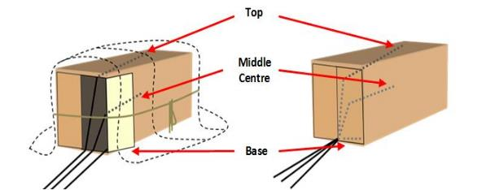
4.2.3 If a consignment consists of more than one un–sheeted container then each container is a separate fumigation and needs to have a minimum of three sampling tubes in each container.
4.2.4 Two containers under a single gas–tight sheet is considered a single enclosure and must have at least three sampling tubes placed as close as practicable to (Figure 2):
- the top of the commodity in the middle of each container
- the base of the commodity at the door in either container.
Figure 2 Concentration sampling tube positions within two containers under a single enclosure
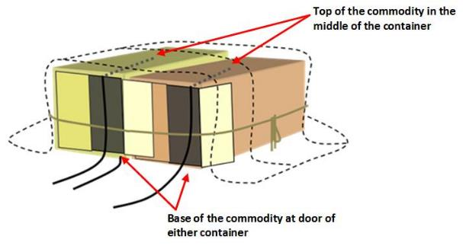
4.2.5 Three or more containers under a single gas–proof sheet is considered a single enclosure and must have at least one sampling tube placed as close as practicable to the top of the commodity in the middle of each container (Figure 3).
Figure 3 Concentration sampling tube positions within three containers under a single enclosure
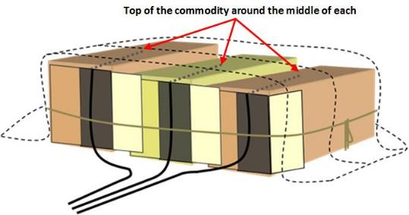
4.2.6 Four containers under a single gas-proof sheet is considered a single enclosure must have at least four sampling tubes, five containers, five sampling tubes and so on.

Fumigant supply pipes
4.3.1 Multiple containers fumigated in a single enclosure must have at least one supply pipe placed in each container.
4.3.2 For fumigations under sheets the supply pipes must be left in position for the duration of the exposure period.
4.3.3 The supply pipes must be sealed once the fumigant has been applied.

Fans
4.4.1 Enclosures must have at least one fan for each 100m³ of volume or part thereof.
4.4.2 Multiple containers fumigated in a single enclosure must have at least one fan placed in each container.

Temperature
4.5.1 The temperature of the entire enclosure and fumigation target must be equal to or above the minimum temperature specified in the treatment schedule before any fumigant can be applied.
4.5.2 Where the fumigation is not performed in a controlled temperature environment, the fumigator must check what the forecast minimum temperature will be during the exposure period for the location closest to the fumigation site. The forecast minimum temperature and the source of the information must be recorded.
4.5.3 Fumigation is not permitted if the forecast minimum temperature for the exposure period is below the specified minimum temperature unless the temperature can be raised to and maintained at or above the allowable temperature for the exposure period by using heaters or moving the consignment inside a structure where the temperature can be adequately controlled.
4.5.4 Where the fumigation is performed in a controlled temperature environment, the temperature within the enclosure must be monitored and recorded at least once every 60 seconds.
One (1) temperature monitoring instrument is required for every concentration sampling tube for enclosures larger in volume than 30m³.
Two (2) temperature monitoring instruments are required for enclosures that are 30m³ or less in volume.
4.5.5 One (1) temperature monitoring instrument must be positioned in the enclosure as far as practicable from the heat source. The remaining temperature monitoring instruments must be positioned in different sections of the commodity that are expected to be hardest to heat.
4.5.6 Temperature monitoring instruments used must be accurate to within +/-0.5 °C.
4.5.7 Temperature monitoring and recording instruments used must be calibrated/serviced in accordance with the manufacturer’s requirements.

Calculating the dose
NOTE: There are two approved options for conducting sulfuryl fluoride fumigations in accordance with this methodology, specifically:
- Follow the treatment schedule (initial dose, temperature, duration and retention requirements) prescribed by the relevant regulatory authority, or
- Use an approved third party system (concentration-time (CT) product, duration and retention requirements) prescribed by the relevant regulatory authority.
Section 5 of this methodology does apply to treatment providers using the department’s prescribed treatment schedule (option 1). These treatment providers must adhere to all requirements of the section.
Section 5 of this methodology does not apply to treatment providers using approved third party systems (option 2). These treatment providers must follow the dosage calculation requirements in the approved system.

Dose rate
5.1.1 The dose rate for the appropriate temperature prescribed by the relevant authority must be used for QPS fumigations with sulfuryl fluoride.

Dose calculation
5.3.1 The dose must be calculated by multiplying the dose rate by the volume of the enclosure. The formula is:
Dose (g) = Enclosure Volume (m³) x Dose Rate Concentration (g/m³)

Enclosure volume
5.4.1 If the fumigation is conducted under gas–proof sheets, the external dimensions must be measured each time and used to calculate the volume.
5.4.2 For fixed sized enclosures such as chambers and un–sheeted containers, the internal volume must be used to calculate the volume.

Rounding
5.5.1 Once the dose has been calculated, the amount must be rounded up to next increment that can be accurately measured by the equipment used to dispense the fumigant dose.
5.5.2 The dose must not be rounded up until all calculations have been completed.

Applying the dose

Releasing the fumigant
6.1.1 Fumigant cylinders must be inside the risk area when fumigant is released.
6.1.2 The time that the sulfuryl fluoride injection was completed must be recorded.
6.1.3 The connections in the supply system must be free from leaks.
6.1.4 Scales used to measure the dose applied must be calibrated at least annually and have an accuracy of +/-0.1kg.

Checking for leaks
6.2.1 Suitable electronic leak detection equipment must be used.
6.2.2 Leak detection equipment must be able to detect sulfuryl fluoride concentrations down to at least 20ppm.
6.2.3 Leak detection equipment must be maintained and calibrated in accordance with the manufacturer’s instructions.
6.2.4 During the injection of the dose, the supply system must be checked for leaks. If a leak is detected, the problem must be rectified before continuing to inject the dose.
6.2.5 The fumigation enclosure must be checked for leaks, especially around doors, vents, sheet joins and the bottom of enclosures. If leaks are detected, they must be rectified.

Circulating the fumigant
6.3.1 The fans must be operating prior to and during the injection of the fumigant dose into the enclosure.
6.3.2 The fans must be turned off before taking concentration readings.

Monitoring fumigant concentration levels
NOTE: Section 7 of this methodology does apply to treatment providers using the department’s prescribed treatment schedule. These treatment providers must adhere to all requirements of the section.
Section 7 of this methodology does apply to treatment providers using approved third party systems. These treatment providers must adhere to all requirements of the section except for 7.3.5-7.3.8.

Concentration measuring instruments
7.1.1 Instruments used for measuring fumigant concentrations in the enclosure must be fit for purpose and in good working order.
7.1.2 Concentration measuring instruments must be calibrated and/or serviced according to the manufacturer’s instructions.
7.1.3 The fumigator must have a copy of the user’s manual for the particular instrument they use and must operate the equipment in accordance with the manual.
7.1.4 Concentration measuring instruments must be fitted with any filters as specified by the manufacturer to suit the circumstances of the fumigation.

Monitoring frequency
7.2.1 Concentration readings must be taken at the start of the fumigation and at the end of the exposure period for all fumigations.
Additional readings can be taken at any time during the exposure period to check the concentrations are equal to or above the levels required for an effective treatment.
See 8. Topping-up to compensate for low concentrations for details on topping-up the concentration levels.
7.2.2 Fumigations with exposure periods longer than 24 hours must have concentration readings taken at least every 24 hours in addition to the start and end point readings.

Start time of the fumigation
7.3.1 The fumigation exposure period starts when:
- equilibrium has been established

and
- all concentration readings are equal to or above the required dose concentration [note: does not apply to treatment providers using an approved third party system]

or
- the approved third party system indicates the exposure time has commenced [note: only applies treatment providers using an approved third party system]

7.3.2 Equilibrium is achieved when the highest concentration reading is within 15% of the lowest concentration reading. The formula for calculating equilibrium is:
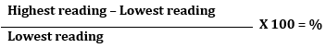
7.3.3 If the result of this calculation is more than 15%, equilibrium has not been achieved and the fans must be turned on again to further circulate the fumigant. Additional readings must then be taken until equilibrium has been achieved or the concentration falls below the standard concentration.
Note: Once initial equilibrium has been achieved, it is not required at any other time.
7.3.4 A concentration reading must be taken from all sampling tubes.
7.3.5 The concentration readings must all be at or above the standard concentration for the relevant treatment schedule in Appendix 3.
7.3.6 If additional fumigant needs to be added before start point has been reached, the amount must be calculated by subtracting the lowest concentration reading from the initial dose rate and multiplying that by the volume of the enclosure.
The formula for this is:
(Initial dose rate – Lowest concentration reading) x Volume
7.3.7 If more fumigant is added to the enclosure before start time is achieved, the time the injection of additional fumigant is completed becomes the new injection completion time for determining the required start time concentration.
7.3.8 All initial concentration readings and the time they were taken must be recorded. This includes any readings taken prior to achieving start point.

Minimum concentration levels
7.4.1 A minimum specified concentration of fumigant, must be maintained within the enclosure during the exposure period. This will be detailed in the relevant prescribed treatment schedule.

End of the exposure period
7.5.1 The elapsed time between the start time and the end time of the fumigation must not be less than the prescribed exposure period.
7.5.2 After the specified exposure period has elapsed, concentration readings from all sampling tubes must be taken. The readings and the time they were taken must be recorded on the Record of Fumigation.
7.5.3 The final concentration readings must all be at or above the required concentration for the required exposure period. If any of the readings are below the required concentration, the fumigation has failed unless the option of end point top-up is permitted.

Topping-up to compensate for low concentrations
NOTE: Section 8 of this methodology does apply to treatment providers using the department’s prescribed treatment schedule. These treatment providers must adhere to all requirements of the section.
Section 8 of this methodology does not apply to treatment providers using approved third party systems. These treatment providers must follow the topping-up requirements in the approved third party system.

Topping-up
8.1.1 If concentration monitoring indicates that fumigant levels are at risk of falling below the required concentration, then the target of the fumigation may not be exposed to the minimum lethal dose needed to for effective treatment. Therefore, in some circumstances, the fumigator can add extra sulfuryl fluoride to increase the concentration levels to prevent the fumigation from failing.
8.1.2 Toping up must be undertaken when the lowest concentration reading is below the standard concentration (Figure 4 – A) and above the Minimum concentration to allow top-up (Figure 4 – B).
8.1.3 The top–up amount must be applied to the enclosure the same way as the original dose as per section 6 Applying the Dose
8.1.4 After adding the top–up amount and allowing time for the extra fumigant to circulate, a concentration reading must be taken from the sampling tube that had the lowest reading to verify that the fumigant level is back above the standard concentration.
8.1.5 Equilibrium is NOT required.
8.1.6 Details must be recorded on the Record of Fumigation.

Calculating the top-up amount
8.2.1 To calculate the top-up amount, subtract the lowest concentration reading from the initial dose and multiply by the volume of the enclosure (Figure 4).
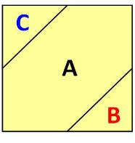
Figure 4 Sulfuryl Fluoride minimum concentration requirement and top-up calculation guide
A Standard concentration. B Minimum concentration to allow top-up. C Maximum top-up concentration. See Appendix 3: Sulfuryl fluoride monitoring tables. Note: (C – lowest concentration reading) x enclosure volume = top-up amount.

8.2.2 Round-up. See 5.4 Rounding.

Restrictions on topping-up
8.3.1 Topping-up the concentration is NOT permitted if:
- the lowest concentration reading is below the minimum concentration to allow top-up
- it will result in exposure to excessive concentrations of sulfuryl fluoride that will adversely affect that commodity.
8.3.2 Where the concentration readings at any of the sampling tubes, at any time, is below the minimum concentration to allow top-up, the fumigation has failed and topping-up is not permitted.

Topping-up during the exposure period
8.4.1 If a top–up is done during the normal exposure period, no extension of the exposure period is required.
8.4.2 Multiple top–ups are permitted during the exposure period.

Topping-up at the end of the exposure period
8.5.1 Topping-up at the end of the exposure period is not permitted.

Ventilating the enclosure

Threshold limit value – time weighted average (TLV-TWA)
9.1.1 The enclosure must be ventilated until the concentration of fumigant within the enclosure falls below the TLV–TWA. The TLV–TWA is 3 ppm unless a lower concentration is imposed by the relevant authorities in the jurisdiction in which the fumigation takes place.
9.1.2 The equipment used for measuring TLV–TWA must be fit for purpose and capable of accurately measuring the actual concentration, not just the presence, of sulfuryl fluoride in the range of 1 to 20 ppm.
9.1.3 Electronic instruments used to measure TLV–TWA must be calibrated and serviced in accordance with the manufacturer’s instructions.

Releasing the fumigant from the enclosure
9.2.1 At the end of the exposure period the fumigant must be fully ventilated from the enclosure in a controlled and safe manner.
9.2.2 An assessment of the risks must be done to manage the ventilation process so that unprotected personnel in the vicinity are not exposed to unsafe levels of fumigant. The assessment must take into account:
- prevailing wind direction
- location and proximity of unprotected personnel
- establishment of a temporary buffer zone around the enclosure that is sufficient to prevent unprotected personnel in the vicinity from being exposed to unsafe levels of sulfuryl fluoride prevention of unprotected personnel entering the buffer zone during ventilation.
9.2.3 Unprotected personnel are not permitted to enter the risk area until the fumigator verifies that concentration in the area and throughout the enclosure is at or below the TLV–TWA.
9.2.4 If the consignment is fumigated in the shipping container/s that will be used to transport the goods, then each container must be checked individually to verify gas clearance below
TLV–TWA.

Releasing the consignment from the fumigator’s control
9.3.1 The consignment can only be released from the fumigators control once the following conditions have been met:
- The fumigation has been performed in accordance with requirements
or
- The fumigation has failed and it is subsequently unsuitable for further treatment with sulfuryl fluoride, requiring the consignment to be sent for an alternative treatment option
and
- The fumigant concentrations have been verified to the TLV–TWA or below.
9.3.2 The TLV–TWA readings and the time they were taken must be recorded.

Documentation

Record of Fumigation
10.1.1 The fumigator must record sufficient information to demonstrate that the fumigation complied with the requirements of this methodology and any additional regulatory requirements.
10.1.2 At a minimum the Record of Fumigation must include the following:
- job identification
- client or customer name
- start date of the fumigation
- location – the site address where the fumigation was performed
- a description of the consignment – including quantity
- the target of the fumigation – why is the fumigation being performed
- consignment identification – container number/s, bill of lading or other means to clearly identify the consignment
- a declaration that the consignment is suitable for fumigation with the requirements set out at in section 1. Prior to Fumigation
- type of enclosure and enclosure volume
- the specified dose rate [note: does not apply to treatment providers using an approved third party system]
- CT required [note: only applies treatment providers using an approved third party system]
- exposure period
- the forecast minimum temperature or minimum temperature maintained within the enclosure (if heated)
- the dose – amount of fumigant to be used and the actual dose applied
- the amount and percentage of chloropicrin applied (if applicable)
- the time the injection of the dose into the enclosure was completed
- all concentration readings from each sampling tube and the time they were taken
- the actual CT achieved [note: only applies treatment providers using an approved third party system]
- the TLV–TWA readings and the time they were taken
- the name and signature of the fumigator–in–charge.
Note: See Appendix 1: Example record of fumigation for an example Record of Fumigation.
10.1.3 Treatment providers using an approved third party system must also include the fumigant concentration monitoring output produced by the third party system as an attachment to each Record of Fumigation.
10.1.4 The Record of Fumigation must be completed on the fumigation site as the tasks are performed and copies must be maintained for audit purposes for a minimum of two years.
10.1.5 Temperature records (see 4.5 Temperature) must be created and maintained for audit purposes for a minimum of two years.
10.1.6 Recording of false or misleading information is not permitted under any circumstances.

Fumigation treatment certificate
10.2.1 A fumigation treatment certificate can be issued by a suitably accredited person once the fumigation has been performed in accordance with the requirements.
10.2.2 At a minimum the fumigation certificate must include the following:
- treatment provider’s letterhead including name and physical address
- treatment provider’s AEI (where applicable)
- certificate number
- description of the consignment – including quantity
- the target of the fumigation (commodity/non-commodity/both)
- consignment identification/link – container number/s, bill of lading or other means to clearly identify the consignment
- Country of origin, country of destination and port of loading
- name and address of exporter
- name and address of importer
- date and time the fumigation was completed
- date and time the ventilation was commenced
- place of fumigation
- exposure time period
- minimum temperature details
- applied dose rate (does not apply to treatment providers using approved third party systems)
- CT achieved (only applies to treatment providers using approved third party systems)
- end point concentration
- final TLV–TWA reading/s
- type of fumigation enclosure
- container number/s (where applicable)
- a declaration that the consignment met all suitability requirements set out in section
1. Prior to Fumigation
- a declaration that the fumigation met all of the compliance requirements set out in this methodology
- the name and signature of the fumigator–in–charge.
Note: See Appendix 2: Example fumigation certificate for an example Fumigation Certificate.
10.2.3 All sections of the fumigation certificate are mandatory and must be filled out accurately.
10.2.5 The fumigation certificate must accompany the consignment to verify that it has been effectively treated for QPS purposes.

Appendix 1a: Example record of fumigation
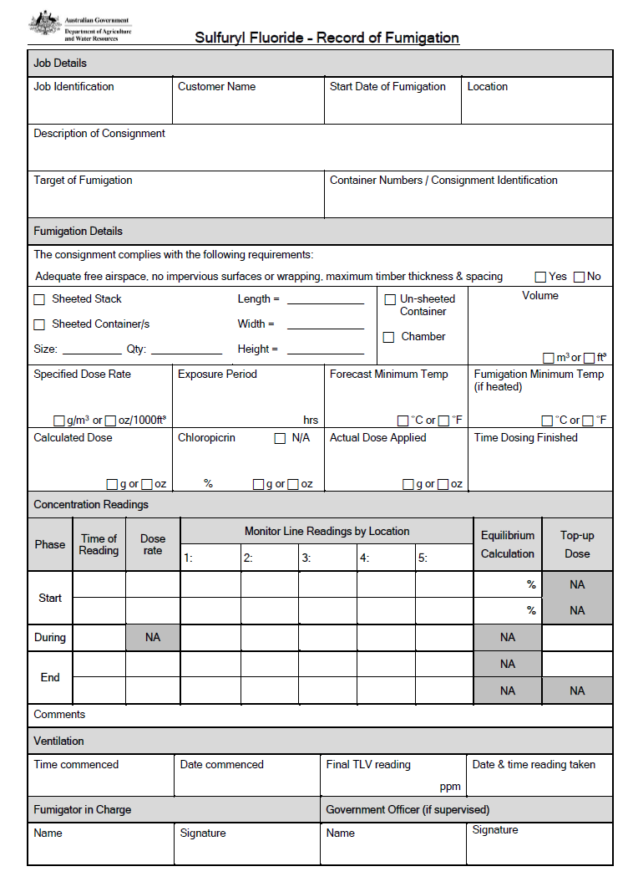

Appendix 1b: Example record of fumigation (3rd Party Approved System)
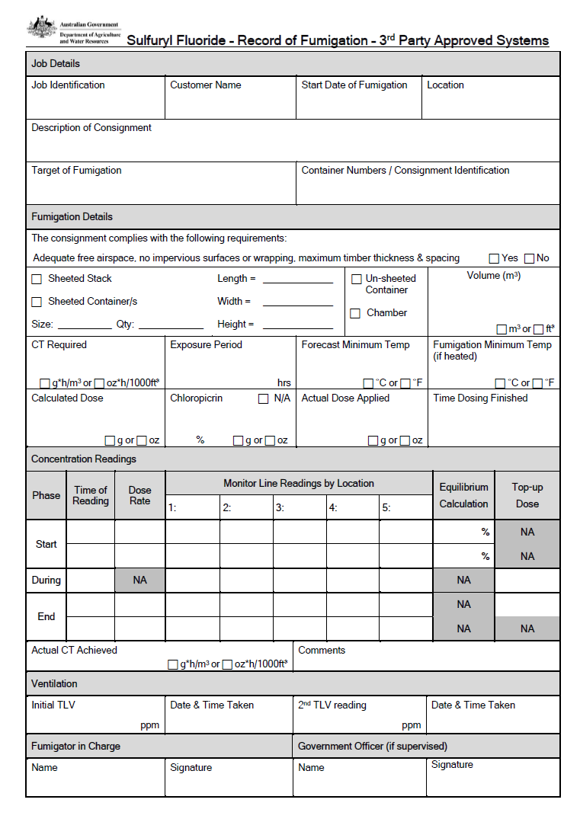

Appendix 2a: Example fumigation certificate
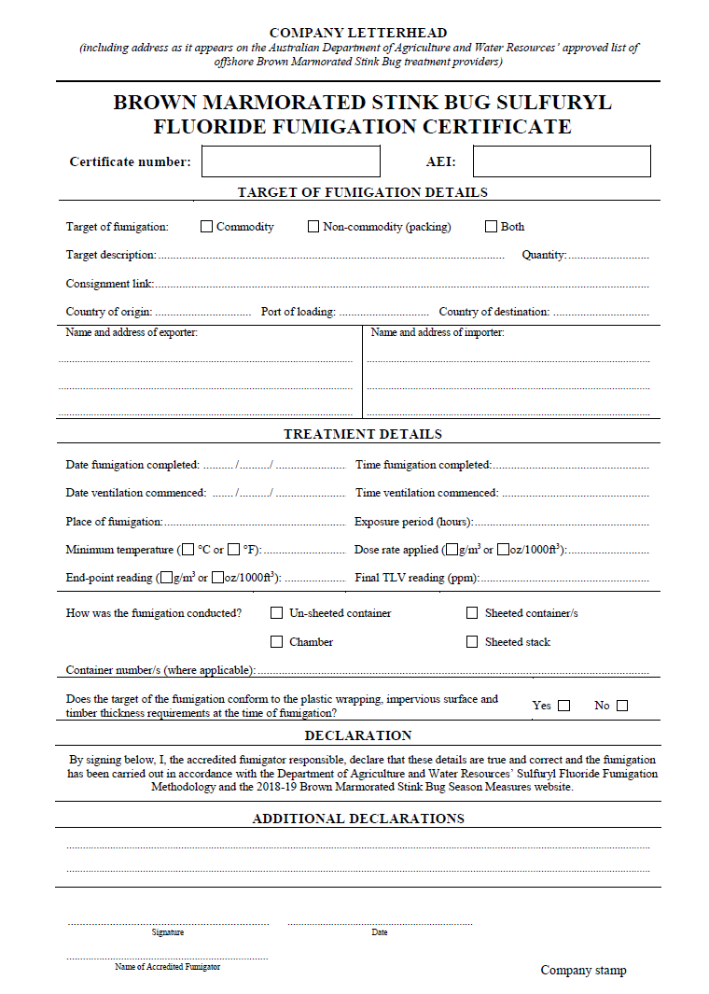

Appendix 2b: Example fumigation certificate (3rd Party Approved System)
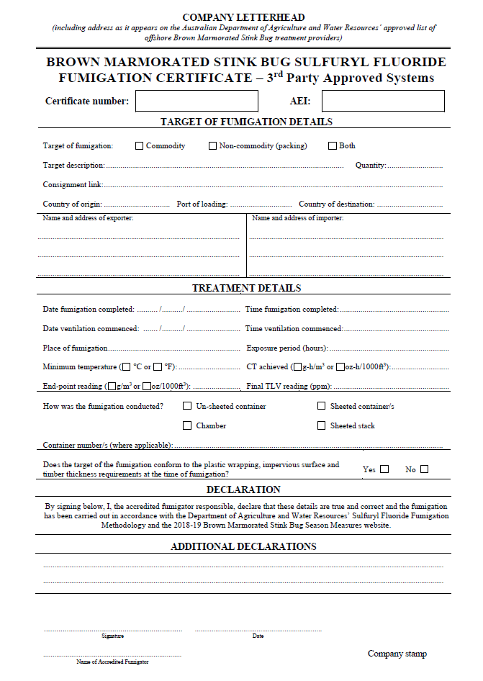

Appendix 3: Sulfuryl fluoride monitoring tables
Figure 5 Sulfuryl fluoride monitoring table for a 24 hour exposure period
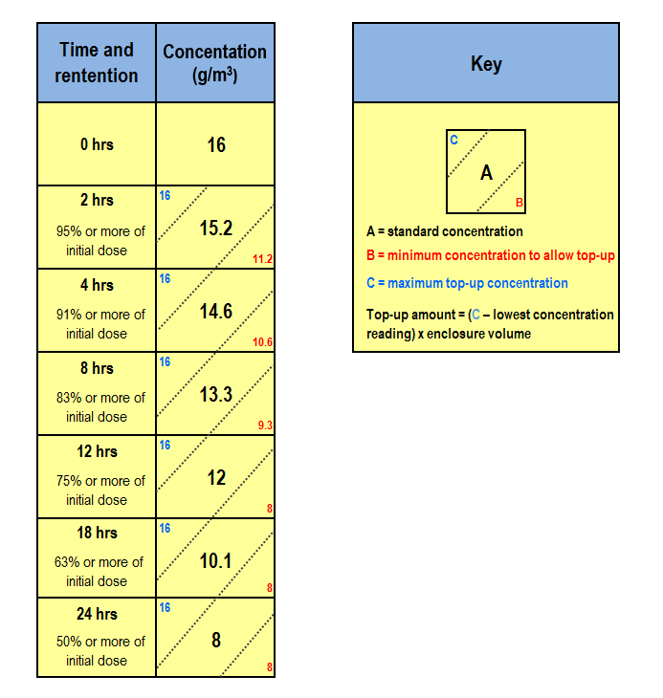

Figure 6 Sulfuryl fluoride monitoring table for a 12 hour exposure period
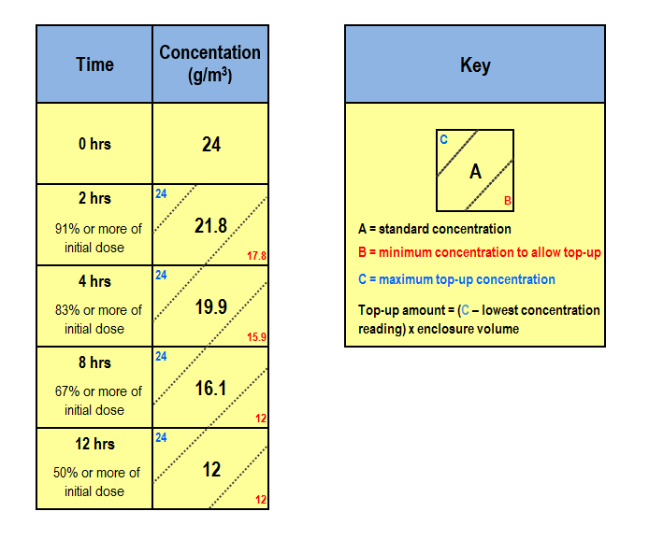

Glossary
Ambient temperature | The air temperature of the surrounding area where the fumigation will be conducted.
Buffer zone | The area around the enclosure, outside of which, the concentration levels of sulfuryl fluoride should not exceed the TLV–TWA during ventilation.
Commodity | The item or goods that are being exported or imported.
Concentration | The amount of fumigant present at a certain point in the fumigation enclosure, usually expressed as grams per cubic metre (g/m³).
Consignment | Refers collectively to the commodity, any packing materials used and the mode of transport such as a shipping container.
Dosage | The cumulative concentration of fumigant in the enclosure over the exposure period. Also referred to as the Concentration by Time Product (CT Product) normally expressed as gram hours per cubic metre.
Dose | The amount of fumigant applied to a fumigation enclosure.
Dose rate | The prescribed concentration of fumigant to be used per unit of volume and the exposure period.
Enclosure | Any gas–tight space intended to contain sufficient concentrations of fumigant for a period of time. Common examples of fumigation enclosures used for QPS fumigations are sealed shipping containers, gas–proof sheets sealed to an impervious floor and purpose–built chambers
Equilibrium | An even distribution of fumigant throughout the enclosure.
Exposure period | The amount of time, in one continuous block, that the consignment must be exposed to sufficient concentration levels of fumigant to be lethal to the targeted pests.
Free air space | Empty space in the enclosure between, above or around a commodity.
Fumigant | A chemical, which at a particular temperature and pressure can exist in a gaseous state in sufficient concentration and for sufficient time to be lethal to insects and other pests
Fumigation sheets | A sheet (or tarpaulin) that is made of material impervious to the fumigant used to create a temporary fumigation enclosure.
ISPM15 | International Standards for Phytosanitary Measures No. 15 – Regulation of wood packaging material in International trade
Minimum top-up concentration | The absolute minimum concentration below which levels fumigant concentration must not fall at any time during the exposure period.
Sampling tube | A small diameter tube used to draw a sample of gas/air mixture from within a fumigation enclosure to measure the fumigant concentration.
Pascal (Pa) | The standard international unit for pressure. Standard atmospheric pressure is 101.325 kPa.
Permeability | The rate at which a substance (such as sulfuryl fluoride) passes through a material (such as a fumigation sheet).
Pest | Any animal, plant or other organism that may pose a threat to the community or the natural environment.
Quarantine pest | A pest of potential economic and/or environmental importance to an area where it is not yet present, or is present but not widely distributed and is being officially controlled.
Quarantine and Pre–shipment (QPS) | - Quarantine treatment applications are treatments conducted to prevent the introduction, establishment and or spread of quarantine pests.  - Pre-shipment treatment applications are treatments conducted prior to export to meet the official requirements of the importing or exporting country.
Record of fumigation | A document that records the relevant information to demonstrate the fumigation complied with requirements.
Relevant authority | The government department, ministry or agency responsible for animal and plant biosecurity in the importing or exporting country.
Risk area | The area around the enclosure to which access is restricted to personnel wearing personal protective equipment.
Sheet fumigation | A process of creating a gas–tight enclosure by covering/enclosing the commodities to be fumigated under a gas–proof sheet.
Shipping container | Standardised transportation units that can be moved from one mode of transport to another without needing to unload the contents.
Sorption/sorptive | A physical and chemical action by which one substance becomes attached to another. De-sorption is the reversal of this process.
Standard concentration | The fumigant concentration below which the fumigation will not be effective unless additional fumigation is added to the enclosure to compensate.
Target of the fumigation | The target of the fumigation may be the commodity, packaging material or both.
Treatment | Application of a set of specified requirements intended to kill pests and diseases that may be associated with a consignment.
Treatment Schedule | The specified treatment requirements (initial dose, minimum exposure period, minimum temperature, minimum end point concentration %).
Threshold Limit Value – Time Weighted Average (TLV–TWA) | TLV–TWA is the maximum concentration of fumigant that a person can be repeatedly exposed to in the workplace without harmful effects. This figure is based on an 8 hour day, 40 hour working week.

