Methyl bromide fumigation methodology
Version 2.0
© Commonwealth of Australia 2018
Ownership of intellectual property rights
Unless otherwise noted, copyright (and any other intellectual property rights, if any) in this publication is owned by the Commonwealth of Australia (referred to as the Commonwealth).
Creative Commons licence
All material in this publication is licensed under a Creative Commons Attribution 4.0 International Licence except content supplied by third parties, logos and the Commonwealth Coat of Arms.
Inquiries about the licence and any use of this document should be emailed to copyright@agriculture.gov.au.
Cataloguing data
This publication (and any material sourced from it) should be attributed as: Department of Agriculture and Water Resources 2018, Methyl bromide fumigation methodology, Canberra, July. CC BY 4.0.
This publication is available at agriculture.gov.au/publications.
Department of Agriculture and Water Resources
Postal address GPO Box 858 Canberra ACT 2601
Telephone 1800 900 090
Web agriculture.gov.au
The Australian Government acting through the Department of Agriculture and Water Resources has exercised due care and skill in preparing and compiling the information and data in this publication. Notwithstanding, the Department of Agriculture and Water Resources, its employees and advisers disclaim all liability, including liability for negligence and for any loss, damage, injury, expense or cost incurred by any person as a result of accessing, using or relying on any of the information or data in this publication to the maximum extent permitted by law.

Purpose
This methodology sets out the minimum requirements for treatment providers performing methyl bromide fumigations on commodities and/or associated packaging suited to such treatments for Quarantine and Pre-shipment (QPS) purposes. This methodology is the basis for compliance auditing of treatment providers to monitor their performance of effective QPS treatments with methyl bromide.
Importing countries have the right to impose more stringent treatment conditions to address their individual biosecurity risks. In such cases, those additional conditions take precedence over the requirements of this methodology and must be complied with to the satisfaction of the relevant authority of the importing country.
Fumigation treatment providers registering to perform treatments in accordance with these requirements must have the equipment, facilities, accredited fumigators and management and administrative procedures necessary to ensure that all relevant treatments comply with these requirements.
Countries receiving treatment certification through this system expect the treatment has been undertaken in accordance with this methodology. Treatment providers found to be wilfully and consistently not complying with the requirements of this methodology and/or other specified treatment conditions will have their registration status changed to ‘unacceptable’ until they can demonstrate satisfactory compliance.
Methyl bromide is listed as a category 1 ozone depleting substance under the Montreal Protocol 1992. Performing methyl bromide fumigations in accordance with these requirements will reduce the use of methyl bromide by minimising the need for re-treatment of consignments due to ineffective fumigations caused by poor fumigation practices.

Scope
This document applies to commercial and government treatment providers performing QPS methyl bromide fumigation treatments for countries that have adopted a specific methyl bromide treatment schedule.
This document is not intended to specifically cover the performance of methyl bromide fumigation treatments under ISPM 15. However, the basic principles, requirements and recommendations described in this document and the associated guideline are still generally applicable.
Even though the basic principles and requirements would be relevant this document is not intended to specifically cover fumigations of vessels (whether it is the vessel itself or its cargo) silos or other storage facilities, buildings or other fumigations that are not done in the types of enclosure described herein and not related to import or export.

How to use this document
Some of the requirements in this methodology only apply in certain circumstances, generally related to the type of enclosure used or fumigating perishables. It is important for the fumigators and compliance auditors to understand the purpose of the requirements and the outcomes they are intended to achieve and the particular circumstances in which they apply.
This document should be read in conjunction with the Guide to performing QPS fumigations with methyl bromide, which provides information on how to meet these requirements in commonly encountered situations.
Contents
Purpose iii
Scope iii
How to use this document iv
1 Prior to fumigation 1
1.1 Target of the fumigation 1
1.2 Consignment suitability 1
1.3 Free airspace 1
1.4 Timber thickness and spacing 1
1.5 Impervious wrappings, coatings and surfaces 1
1.6 Impervious wrapping perforation requirements 2
1.7 Site suitability 2
2 Safety 2
2.1 Risk assessment 2
2.2 Risk area 3
2.3 Personal protective equipment (PPE) 3
3 Fumigation enclosures 4
3.1 Gas-tightness 4
3.2 Sheeted enclosures 4
3.3 Un-sheeted shipping containers 4
3.4 Fumigation chambers 5
3.5 Pressure testing 5
4 Preparing the fumigation enclosure 5
4.1 Concentration sampling tubes 5
4.2 Concentration sampling tube placement—non-perishable commodities 5
4.3 Concentration sampling tube placement—perishable commodities 7
4.4 Temperature probes for perishable commodities 7
4.5 Fumigant supply pipes 8
4.6 Fans 8
5 Calculating the dose 8
5.1 Dose rate 8
5.2 Dose rate compensation for temperatures below 21 °C 8
5.3 Temperature 8
5.4 Dose calculation 9
5.5 Enclosure volume 9
5.6 Chloropicrin 9
5.7 Rounding 9
6 Applying the dose 9
6.1 Vaporising the methyl bromide 9
6.2 Checking for leaks 10
6.3 Circulating the fumigant 10
7 Monitoring fumigant concentration levels 10
7.1 Concentration measuring instruments 10
7.2 Monitoring frequency 10
7.3 Start time of the fumigation 11
7.4 Minimum concentration levels 12
7.5 End of the exposure period 12
8 Topping-up to compensate for low concentrations 12
8.1 Topping-up 12
8.2 Calculating the top-up amount 13
8.3 Restrictions on topping-up 13
8.4 Topping-up during the exposure period 13
8.5 Topping-up at the end of the exposure period 13
9 Ventilating the enclosure 14
9.1 Threshold limit value—time-weighted average (TLV-TWA) 14
9.2 Releasing the fumigant from the enclosure 14
9.3 Releasing the consignment from the fumigator’s control 14
10 Documentation 15
10.1 Record of Fumigation 15
10.2 Fumigation treatment certificate 15
Appendix 1: Example record of fumigation 17
Appendix 2: Example record of fumigation for perishable commodities 18
Appendix 3: Example fumigation certificate 19
Appendix 4: Methyl bromide monitoring table 20
Appendix 5: Concentrations for dose rates and times 21
Appendix 6: Concentrations for dose rates for fumigations that require 80% retention 22
Glossary 23

Tables
Table 1 Time of concentration readings after release and initial concentration dose rate percentage required 11

Figures
Figure 1 Concentration sampling tube positions within a single enclosure 6
Figure 2 Concentration sampling tube positions within two containers under a single enclosure 6
Figure 3 Concentration sampling tube positions within three containers under a single enclosure 7
Figure 4 Methyl bromide minimum concentration requirement and top-up calculation guide 13

1 Prior to fumigation

Target of the fumigation
1.1.1 The fumigator must know what the target of the fumigation is.
1.1.2 The target of the fumigation must be recorded on the fumigation documentation.

Consignment suitability
1.2.1 The fumigator must determine if the consignment is suitable for fumigation with methyl bromide.
1.2.2 If the consignment does not conform to the suitability requirements remedial action must be taken or an alternative acceptable treatment method used.

Free airspace
1.3.1 There must be free space throughout the enclosure to allow the fumigant to freely circulate around the target of the fumigation.
1.3.2 There must be sufficient free airspace to permit the positioning of sampling tubes in appropriate locations within the enclosure. See 4.1 Concentration sampling tubes
1.3.3 Some treatments may specify a maximum load factor in the enclosure. The volume of commodity must not exceed the specified load factor as a proportion of the enclosure volume and must be stacked so there is sufficient separation between items to allow the fumigant to circulate freely and penetrate easily into boxes, bags or other types of packaging.
1.3.4 For perishable commodities, the following free air space requirements apply unless otherwise stated in the treatment schedule being applied:
- a maximum load factor of 80%
- packages must be placed on pallets or raised off the ground by at least 100mm by other means.

Timber thickness and spacing
1.4.1 Untreated timber products must have at least one physical dimension which is less than 200 mm thick.
1.4.2 Timber and timber product fumigations must be conducted before any surface coating are applied, unless all parts of the timber or timber product have at least one uncoated surface and a maximum thickness of 100 mm from the uncoated surface.
1.4.3 Where timber is the target of the fumigation it must be separated by a minimum of 5 mm of airspace every 200 mm. This separation can be horizontal or vertical.

Impervious wrappings, coatings and surfaces
1.5.1 The target of the fumigation must not be coated in materials that will prevent the methyl bromide from penetrating into the target of fumigation such as lacquers, paints, waxes, natural oils, veneers or plastic wraps.
1.5.2 Impervious wrappings must be removed, opened or slashed prior to fumigation in such a way to allow methyl bromide to come into contact with and, if needed, penetrate into the target of the fumigation.
1.5.3 Requirement 1.5.2 is not necessary if the wrapping complies with 1.6 Impervious wrapping perforation requirements.
1.5.4 Where the target of fumigation is a perishable commodity, all packaging material must also be fumigated.
1.5.5 Due to the short exposure periods for many perishable commodities, all packaging must be opened or otherwise arranged as follows to allow the fumigant to readily circulate around and into the target of the fumigation:
- Products that are tightly packed into cartons in plastic sleeves (e.g. Cut flowers) must be loosened within boxes to ensure adequate gas penetration during fumigation.
- Polythene type liners or non-perforated liners must be opened at the top.
- If open ends of plastic sleeves are packed together in the middle of the carton, the cartons must be re-packed with the open ends be placed towards the sides of the cartons.
- Cartons without ventilation holes or with flowers in plastic sleeves obscuring the holes must be stacked with the tops open or with holes punctured in the sides.

Impervious wrapping perforation requirements
1.6.1 Impervious wrappings must have 4 or more holes of 6 mm diameter or 5 or more holes of 5 mm diameter for every 100 mm x 100 mm of surface area. Wrappings with at least 6 pinholes per 10 mm x 10 mm surface area are also acceptable.
1.6.2 The wrapping must be in a single layer so the perforations are not blocked by the wrapping overlapping itself.

Site suitability
1.7.1 The fumigation site must:
- have adequate space to establish a risk area around the enclosure
- allow for safe ventilation
- be flat and even
- be well ventilated
- have power available, either mains or generator.

Safety

Risk assessment
2.1.1 Before commencing any fumigation a risk assessment must be carried out to determine if any hazards are present and evaluate the potential consequences to:
- fumigation personnel
- people in the vicinity
- occupants of surrounding buildings.
2.1.2 Appropriate control measures must be in place to address the hazards identified.
2.1.3 The risks must be reviewed as needed to respond to changing circumstances and the control measures must be adjusted accordingly.
2.1.4 The designated fumigator-in-charge is responsible for the safe conduct of the fumigation.

Risk area
2.2.1 A risk area must be established around the perimeter of the enclosure warning people the fumigation is taking place.
2.2.2 The risk area must be demarcated by a physical barrier for the duration of the fumigation.
2.2.3 The size of the risk area should be set according to the risk but must not be less than:
- 3 metres from the enclosure outdoors
- 6 metres from the enclosure inside a building or structure.
2.2.4 For fumigations in a chamber, see 3.4 Fumigation chambers, a risk area is not required after the fumigant has been applied provided that the chamber is locked from the time the fumigant is ready to be applied until the fumigant has been ventilated and the concentration verified at or below the TLV–TWA. See 9.1 Threshold limit value—time-weighted average (TLV–TWA).
A risk area must still be established according to requirement 2.2.3 and personal protective equipment must be worn while injecting the fumigant into the chamber to protect the fumigator and others against accidental exposure to the fumigant from a failure in the supply system.
2.2.5 Warning signs must be placed around the enclosure. They must:
- be large enough to be visible from a reasonable distance
- be visible from all angles of approach
- display easily understood symbols indicating danger and/or toxic gas is in use
- provide contact details of the fumigator
- be in a language or languages appropriate to the location.
2.2.6 The risk area, with the exception of chamber fumigations, must be in force from the time immediately prior to connection of the methyl bromide supply (either cylinder or can) to the supply system up until the gas concentration in the risk area and the enclosure is verified at or below the TLV–TWA.
2.2.7 Anyone entering the risk area while it is in force must be wearing appropriate Personal Protective Equipment (PPE) at all times.

Personal protective equipment (PPE)
2.3.1 Suitable respiratory protection must be worn at all times inside the risk area while it is in force.
2.3.2 Respiratory protection must be worn at all times when inside the buffer zone during ventilation. See 9 Ventilating the enclosure.
2.3.3 A full-face respirator must be:
- operated in accordance with the manufacturer’s instructions
- fitted with the correct gas filter canister (AX for methyl bromide) and replaced in accordance with the manufacturer’s instructions
- maintained in good condition with all valves clean and intact
- able to form an airtight seal against the face of the fumigator.
2.3.4 Self-contained breathing apparatus must be:
- operated in accordance with the manufacturer’s instructions
- used only by properly trained personnel
- maintained in good working order
- refilled from a safe source.

Fumigation enclosures

Gas-tightness
3.1.1 All fumigation enclosures must be sufficiently gas-tight to retain the fumigant for the duration of the exposure period and maintain the concentrations at or above the requirements.

Sheeted enclosures
3.2.1 The surface on which the sheeted enclosure will be created must be:
- impervious to methyl bromide or covered with a gas-proof sheet if the surface is not impervious
- free of debris that might prevent a gas-tight seal or damage the sheet
- free of cracks and drains or other openings that will permit excessive leakage.
3.2.2 The fumigation sheets must be impervious to methyl bromide. They must be able to retain the required concentration for the duration of the fumigation without needing to add additional methyl bromide due to permeation through the sheet.
3.2.3 A gas-tight seal must be created between the fumigation surface and the sheet.
3.2.4 If one or more shipping container is fumigated in a sheeted enclosure at least one door of each container must be open during the fumigation.

Un-sheeted shipping containers
3.3.1 A shipping container can be used as a fumigation enclosure if it can be sealed to make it adequately gas-tight. The fumigator must:
- check the container for any visible holes or damage that would make it unsuitable
- seal the air vents from the outside
- install sampling tubes—see 4.1 Concentration sampling tubes
- install a fan—if there is insufficient space the container must be fumigated as a sheeted enclosure
- arrange the tubes and leads so they exit the container where the doors meet at the base of the container
- create a barrier to reduce air flow under the container.
3.3.2 The methyl bromide must be applied through the door seals and the supply pipe must be removed after the process is complete. This is easiest to do through the door seals where they meet at the top of the container.
3.3.3 Where a false door is fitted to create a gas tight seal, the supply pipe, sampling tubes and power leads must pass through the false door.
3.3.4 Where an un-sheeted shipping container fumigation is conducted on a skeletal trailer, leak checks must be conducted on the underside of the container. A barrier to reduce airflow under the container is not required.
3.3.5 Shipping containers under gas must not be moved until they have been ventilated.
3.3.6 If the target of the fumigation includes the exterior of the container, for example Giant African Snail treatments, the container(s) must be enclosed under gas-proof sheets.

Fumigation chambers
3.4.1 Fumigation chambers are permanent structures designed specifically for fumigation. To be considered a fumigation chamber for the purposes of this methodology they must:
- be constructed from rigid materials on all sides, including the door
- be permanently sealed along all joins between the walls, roof and floor
- be gas-tight once the door is closed without the need to use tape, sealant, sand snakes or any other means.
- not have anything, such as sampling tubes, supply pipes or electrical leads, enter the chamber through the door that will interfere with the seal
- have an inbuilt extraction system that actively removes the fumigant from the enclosure
- pass a pressure test at least every six months according to 3.5 Pressure testing.

Pressure testing
3.5.1 Raise the pressure in the enclosure by 250 Pa. Count the seconds it takes to fall from 200 Pa to 100 Pa. If the time is 10 seconds or more the enclosure has passed the pressure test and is considered gas-tight for fumigation purposes.
3.5.2 The pressure test must be performed with the enclosure set up ready for fumigation. Sampling tubes, supply pipes and electrical leads must be in place during the pressure test as they would be for a fumigation.

Preparing the fumigation enclosure

Concentration sampling tubes
4.1.1 Each sampling tube must be clearly identified according to their location within the enclosure.
4.1.2 The sampling tubes must be free of kinks and blockages.
4.1.3 The diameter of the sampling tubes must fit the inlet of the concentration measuring instrument.

Concentration sampling tube placement—non-perishable commodities
4.2.1 Enclosures that are 30 m³ or less in volume require at least one sampling tube positioned as near as practicable to the top centre of the commodity.
4.2.2 Enclosures larger in volume than 30 m³ must have at least three samplings tubes. The sampling tubes must be positioned to check that even distribution of the fumigant has been achieved (Figure 1). The tubes must be placed as close as practicable to:
- the top of the commodity at one end of the enclosure
- the centre of the commodity around the middle of the enclosure
- the base of the commodity at the opposite end of the enclosure from the top sampling tube.
Figure 1 Concentration sampling tube positions within a single enclosure
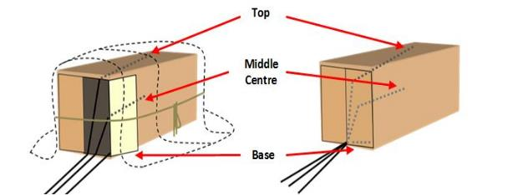
4.2.3 If a consignment consists of more than one un-sheeted container then each container is a separate fumigation and needs to have a minimum of three sampling tubes in each container.
4.2.4 Two containers under a gas-tight sheet is a single enclosure and must have at least three sampling tubes placed as close as practicable to (Figure 2):
- the top of the commodity in the middle of each containers
- the base of the commodity at the door in either container.
Figure 2 Concentration sampling tube positions within two containers under a single enclosure
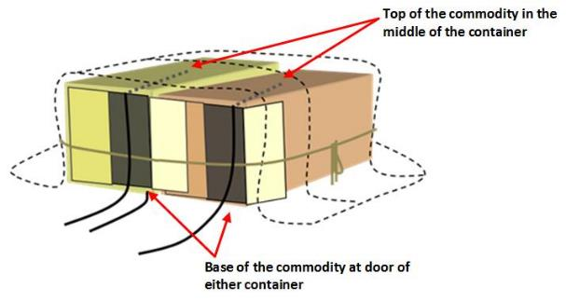
4.2.5 Three or more containers under a gas-proof sheet is a single enclosure and must have at least one sampling tube placed as close as practicable to the top of the commodity in the middle of each container (Figure 3).
Figure 3 Concentration sampling tube positions within three containers under a single enclosure
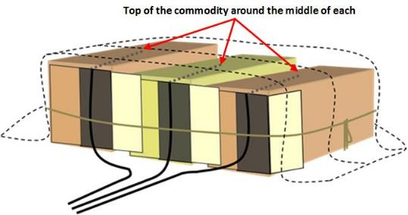
Four containers in one enclosure must have at least four sampling tubes, five containers, five sampling tubes and so on.

Concentration sampling tube placement—perishable commodities
4.3.1 All perishable fumigations must have at least three sampling tubes placed within the middle of packaging, and in the positions specified in 4.3.3, to demonstrate that the treatment fumigant concentration is reached and maintained for the full exposure period within the commodity.
4.3.2 For cut flowers, this is within a sleeve or bunch in the centre of a carton. For other produce, this is in the centre of the carton.
4.3.3 Where cartons are stacked in the enclosure, sampling tubes must be placed inside cartons located in the following positions:
- the top carton at one end of the enclosure
- the centre carton in the middle of the enclosure
- the bottom carton at the opposite end of the enclosure from the top sampling tube.
4.3.4 Where different types packaging are present, sampling tubes must be placed in a representative carton of each packing type.

Temperature probes for perishable commodities
4.4.1 Where the treatment schedule requires the commodity temperature of perishable fumigations is used for dose calculations, temperature readings must be taken by:
- For fruit and vegetables, the pulp temperature must be measured by inserting temperature probes into the centre of a piece, or pieces, of fruit or vegetable in the middle of a carton, ensuring that the whole temperature probe is covered.
- For cut flowers, leaf or stem material, temperate probes must be placed within the bunch in the middle of a carton.
4.4.2 At least three temperature readings must be taken from different cartons in different locations and, if applicable, different varieties within the consignment.
4.4.3 The temperature probes must be maintained to an accuracy of at least plus or minus (+/-) 1 °C.

Fumigant supply pipes
4.5.1 Multiple containers fumigated in a single enclosure must have at least one supply pipe placed in each container.
4.5.2 For fumigations under sheets the supply pipes must be left in position for the duration of the exposure period.
4.5.3 The supply pipes must be sealed once the fumigant has been applied.

Fans
4.6.1 Enclosures must have at least one fan for each 100 m³ of volume or part thereof.
4.6.2 Multiple containers fumigated in a single enclosure must have at least one fan to be placed in each container.

Calculating the dose

Dose rate
5.1.1 The dose rate for the appropriate temperature prescribed by the relevant authority must be used for QPS fumigations with methyl bromide.

Dose rate compensation for temperatures below 21 °C
5.2.1 If the treatment rate is set with a minimum of 21 °C and the temperature within the enclosure is expected to fall below 21 °C at any time during the exposure period, the dose rate must be adjusted to compensate for the lower temperature.
5.2.2 In the absence of any other specific schedule set by the relevant authority the following compensation must be made: For each 5 °C, or part thereof, the temperature is expected to fall below 21 °C add 8 g/m³ to the prescribed dose rate.

Temperature
5.3.1 The temperature of the consignment must be equal to or above the minimum allowable temperature before any fumigant can be applied.
5.3.2 Unless stated otherwise in a specific treatment schedule, fumigation of non-perishable commodities is not permitted if the ambient minimum temperature is forecast to fall below 10 °C.
5.3.3 Unless stated otherwise in a specific treatment schedule, fumigation of perishables is not permitted if the commodity temperature is below 10 °C.
5.3.4 The commodity temperature of perishable commodities must be measured according to 4.4 Temperature probes for perishable commodities and the lowest recorded temperature used to calculate the dose rate. See 5.2 Dose rate compensation for temperatures below 21 °C
5.3.5 Where the enclosure is subject to the ambient temperature of the surrounding environment, the fumigator must check what the forecast minimum temperature will be during the exposure period for the location closest to the fumigation site and adjust the dose rate accordingly.
5.3.6 The forecast minimum temperature used and the source of the information must be recorded.
5.3.7 Fumigation is not permitted if the temperature of the enclosure and consignment is expected to fall below any specified minimum temperature during the exposure unless the temperature can be raised to and maintained at or above the allowed minimum temperature by using heaters or moving the consignment inside a structure where the temperature can be adequately controlled.
5.3.8 Where the fumigation is performed in a controlled temperature environment, the temperature within the enclosure must be monitored and recorded. Temperature recording instruments must be placed as far away as practicable from the heat source.

Dose calculation
5.4.1 The dose must be calculated by multiplying the dose rate (including any adjustments) by the volume of the enclosure. The formula is:
Dose (g) = Enclosure Volume (m³) x Dose Rate Concentration (g/m³)

Enclosure volume
5.5.1 If the fumigation is done under gas-proof sheets, the external dimensions must be measured each time and used to calculate the volume.
5.5.2 For fixed sized enclosures such as chambers and un-sheeted containers the internal volume must be used.

Chloropicrin
5.6.1 When methyl bromide is mixed with chloropicrin, compensation must be made to the dose to ensure that full amount of methyl bromide required is applied to the enclosure.
For methyl bromide supplied with 2% chloropicrin the formula is:
Dose = (Volume x Concentration) ÷ 0.98

Rounding
5.7.1 Once the dose has been calculated, the amount must be rounded up to next increment that can be accurately measured by the equipment used to dispense the dose. If the methyl bromide is supplied in cans then the dose must be rounded up to the next full can.
5.7.2 The dose must not be rounded up until all other calculations have been completed.

Applying the dose

Vaporising the methyl bromide
6.1.1 A vaporiser must be used when methyl bromide is applied to the enclosure.
6.1.2 The heat source for the vaporiser must be capable of heating the water in the vaporiser to at least 65 °C and maintaining the temperature at or above this while the methyl bromide is being applied to the enclosure.
6.1.3 If the temperature of the water falls below 65 °C, the rate of methyl bromide release must be slowed or stopped until the water temperature is heated back above 65 °C.
6.1.4 The time methyl bromide injection was completed must be recorded.
6.1.5 The connections in the supply system must be secure and free from leaks.

Checking for leaks
6.2.1 Suitable leak detection equipment must be used.
6.2.2 The leak detection equipment must be sensitive enough to reliably detect methyl bromide concentrations down to 20 ppm.
6.2.3 The leak detection equipment must be maintained and electronic equipment calibrated in accordance with the manufacturer’s instructions.
6.2.4 During the injection of the dose the supply system must be checked for leaks. If a leak is detected the problem must be rectified before continuing to inject the dose.
6.2.5 The fumigation enclosure must be checked for leaks. If leaks are detected they must be rectified.

Circulating the fumigant
6.3.1 The fans must be operating prior to and during the injection of the fumigant dose into the enclosure.
6.3.2 The fans must be turned off before taking concentration readings.

Monitoring fumigant concentration levels

Concentration measuring instruments
7.1.1 The instrument used for measuring fumigant concentrations in the enclosure must be fit for purpose and in good working order.
7.1.2 The concentration measuring instruments must be calibrated and/or serviced according to the manufacturer’s instructions.
7.1.3 The fumigator must have a copy of the user’s manual for the particular instrument they use and must operate the equipment in accordance with the manual.
7.1.4 The instrument must be fitted with any moisture, carbon dioxide or other filters as specified by the manufacturer to suit the circumstances of the fumigation.

Monitoring frequency
7.2.1 Concentration readings must be taken at the start of the fumigation and at the end of the exposure period for all fumigations.
Additional readings can be taken at any time during the exposure period to check the concentrations are equal to or above the levels required for an effective treatment. See 8. Topping-up to compensate for low concentrations for details on topping-up the concentration levels.
7.2.2 Fumigations with exposure periods longer than 24 hours require concentration readings to be taken at least every 24 hours in addition to the start and end point readings.

Start time of the fumigation
7.3.1 The fumigation exposure period starts when:
- all concentration readings are equal to or above the standard concentration
- equilibrium has been established
7.3.2 Equilibrium is achieved when the highest concentration reading is within 15% of the lowest concentration reading.
The formula for calculating equilibrium is:
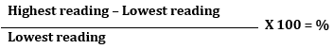
7.3.3 If the result of this calculation is more than 15%, equilibrium has not been achieved and the fans must be turned on again to further circulate the fumigant. Additional readings must then be taken until equilibrium has been achieved or the concentration falls below the standard concentration. Once initial equilibrium has been achieved it is not required at any other time.
7.3.4 A concentration reading must be taken from all sampling tubes.
7.3.5 The concentration readings must all be at or above the standard concentration (Table 1) or as specified in a treatment schedule.
Table 1 Time of concentration readings after release and percentage of initial concentration dose rate required
Time after fumigant release | Per cent of initial dose rate concentration
15 to 30 minutes | 85% or more
30 minutes to 1 hour | 75% or more
More than 1 hour | 70% or more
Note: See Appendix 4 Methyl bromide monitoring table for the standard concentrations required for a range of initial dose rates at specified time increments.
7.3.6 If additional fumigant needs to be added before start point has been reached, the amount must be calculated by subtracting the lowest concentration reading from the initial dose rate and multiplying that by the volume of the enclosure.
The formula for this is:
(Initial dose rate – Lowest concentration reading) x Volume
7.3.7 If more fumigant is added to the enclosure before start time is achieved, the time the injection of additional fumigant is completed becomes the new injection completion time for determining the required start time concentration.
7.3.8 All initial concentration readings and the time they were taken must be recorded. This includes any readings taken prior to achieving start point.

Minimum concentration levels
7.4.1 A minimum concentration of fumigant must be maintained within the enclosure during the exposure period.
7.4.2 The concentration of fumigant must not fall below the levels specified in Appendix 5: Concentrations for dose rates and times, or Appendix 6 where a treatment schedule requires a minimum gas retention of 80%.
Note: Fumigations for ISPM 15 require a minimum gas retention of 50% of the initial dose rate at the end of 24 hours.

End of the exposure period
7.5.1 The elapsed time between the start time and the end time of the fumigation must not be less than the prescribed exposure period.
7.5.2 After the specified exposure period has elapsed concentration readings from all sampling tubes must be taken. The readings and the time they were taken must be recorded on the Record of Fumigation.
7.5.3 The final concentration readings must all be at or above the standard concentration for the required exposure period. If any of the readings are below the standard concentration, the fumigation has failed unless the option of end point top-up is permitted.

Topping-up to compensate for low concentrations

Topping-up
8.1.1 If concentration monitoring indicates that fumigant levels are at risk of falling below the standard concentration, then the target of the fumigation may not be exposed to the minimum lethal dose needed to for effective treatment. Therefore, in some circumstances, the fumigator can add extra methyl bromide to increase the concentration levels to prevent the fumigation from failing.
8.1.2 The top-up amount must be applied to the enclosure in the same way as the original dose, that is:
- vaporised (see 6.1 Vaporising the methyl bromide)
- fans on
- PPE worn.
8.1.3 After adding the top-up amount and allowing time for the extra fumigant to circulate, a concentration reading must be taken from the sampling tube that had the lowest reading to verify that the fumigant level is back above the standard concentration.
8.1.4 Equilibrium is NOT required.
8.1.5 Details must be recorded on the Record of Fumigation.

Calculating the top-up amount
8.2.1 To calculate the top-up amount, subtract the lowest concentration reading from the maximum top-up concentration and multiply by the volume of the enclosure (Figure 4).
Figure 4 Methyl bromide minimum concentration requirement and top-up calculation guide
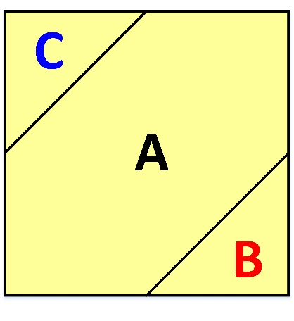
A Standard concentration. B Minimum concentration to allow top-up. C Maximum top-up concentration. See Appendix 4: Methyl bromide monitoring table. Note: (C – lowest concentration reading) x enclosure volume = top-up amount.
8.2.2 Adjust for chloropicrin if applicable. See 5.5 Chloropicrin.
8.2.3 Round-up. See 5.6 Rounding.

Restrictions on topping-up
8.3.1 Topping-up the concentration is NOT permitted if:
- the lowest concentration reading is below the minimum concentration to allow top-up
- the lowest concentration reading is above the maximum top-up concentration
- the fumigation exposure period is less than 12 hours
- it will result in exposure to excessive concentrations of methyl bromide that will adversely affect that commodity.
8.3.2 Where the concentration readings at any of the sampling tubes, at any time, is below the minimum concentration to allow top-up, the fumigation has failed and topping-up is not permitted.

Topping-up during the exposure period
8.4.1 If a top-up is done during the normal exposure period, no extension of the exposure period, is required.
8.4.2 Multiple top-ups are permitted during the exposure period.
8.4.3 If a top-up is required during the second half of the exposure period it is indicative of excessive leakage rather than sorption by the commodity so the enclosure must be re-checked for leaks.

Topping-up at the end of the exposure period
8.5.1 If the lowest of the concentration readings taken at the end of the exposure period is below the standard concentration but equal to or above the minimum to allow top-up, extra fumigant must be added. See 8.2 Calculating the top-up amount.
8.5.2 If a top-up is done at the end of the normal exposure period, the fumigation must be extended for at least another four hours to allow time for the extra fumigant to take effect.
8.5.3 Only one extension of the exposure period is allowed. If, at the end of the extended period, the lowest reading is below the standard concentration as specified for the original exposure period, the fumigation has failed.

Ventilating the enclosure

Threshold limit value—time-weighted average (TLV-TWA)
9.1.1 The enclosure must be ventilated until the concentration of fumigant within the enclosure falls below the TLV–TWA. The TLV–TWA is 5 ppm unless a lower concentration is imposed by the relevant authorities in the jurisdiction in which the fumigation takes place.
9.1.2 The equipment used for measuring TLV–TWA must be fit for purpose and capable of accurately measuring the actual concentration, not just the presence, of methyl bromide in the range of 1 to 20 ppm.
9.1.3 If stain tubes are used, they must be used in conjunction with the sampling pump specified by the manufacturer.
9.1.4 If electronic instruments are used they must be calibrated and serviced in accordance with the manufacturer’s instructions.

Releasing the fumigant from the enclosure
9.2.1 At the end of the exposure period the fumigant must be fully ventilated from the enclosure in a controlled and safe manner.
9.2.2 An assessment of the risks must be done to manage the ventilation process so that unprotected personnel in the vicinity are not exposed to unsafe levels of fumigant. The assessment must take into account:
- prevailing wind direction
- location and proximity of unprotected personnel
- establishment of a temporary buffer zone around the enclosure that is sufficient to prevent unprotected personnel in the vicinity from being exposed to unsafe levels of methyl bromide
- prevention of unprotected personnel entering the buffer zone during ventilation.
9.2.3 Unprotected personnel are not permitted to enter the risk area until the fumigator verifies that concentration in the area and throughout the enclosure is at or below the TLV–TWA.
9.2.4 If the consignment is fumigated in the shipping container(s) that will be used to transport the goods, then each container must be checked individually to verify gas clearance below TLV–TWA.

Releasing the consignment from the fumigator’s control
9.3.1 The consignment can only be released from the fumigators control once the following conditions have been met:
- The fumigation has been performed in accordance with requirements.
or
- The fumigation has failed and it is subsequently unsuitable for further treatment with methyl bromide, requiring the consignment to be sent for an alternative treatment option.
and
- The fumigant concentrations have been verified to the TLV–TWA or below.
9.3.2 The TLV–TWA readings and the time they were taken must be recorded.

Documentation

Record of Fumigation
10.1.1 The fumigator must record sufficient information to demonstrate that the fumigation complied with these requirements.
10.1.2 At a minimum it must include the following:
- job identification
- client or customer name
- start date of the fumigation
- location—the site address where the fumigation was performed
- a description of the consignment
- the target of the fumigation—why is the fumigation being performed
- consignment identification—container number(s), bill of lading or other means to clearly identify the consignment
- a declaration that the consignment is suitable for fumigation with the requirements set out at in section 1 Prior to Fumigation.
- type of enclosure
- enclosure volume
- chamber load factor—expressed as % of chamber volume—this is only for perishables
- the specified dose rate and exposure period
- the forecast minimum temperature and any adjustment made for temperatures below 21 °C (and commodity temperature readings for perishables)
- the dose—amount of fumigant to be used and the actual dose used
- the time the injection of the dose into the enclosure was completed
- the concentration readings from each sampling tube and the time they were taken
- the TLV–TWA readings and the time they were taken
- the name and signature of the fumigator-in-charge.
Note: See Appendix 1: Example record of fumigation for an example Record of Fumigation.
10.1.3 The Record of Fumigation must be completed on the fumigation site as the tasks are performed and copies must be maintained for audit purposes for a minimum of two years.
10.1.4 Recording of false or misleading information is not permitted under any circumstances.

Fumigation treatment certificate
10.2.1 A fumigation treatment certificate can be issued by a suitably accredited person once they are satisfied that the fumigation has been performed in accordance with the requirements.
10.2.2 All sections of the fumigation certificate are mandatory and must be filled out correctly to ensure the certificate can be accepted.
10.2.3 An example fumigation certificate is provided at Appendix 3: Example fumigation certificate.
10.2.4 The fumigation certificate travels with the consignment to state that it has been effectively treated for QPS purposes.

Appendix 1: Example record of fumigation
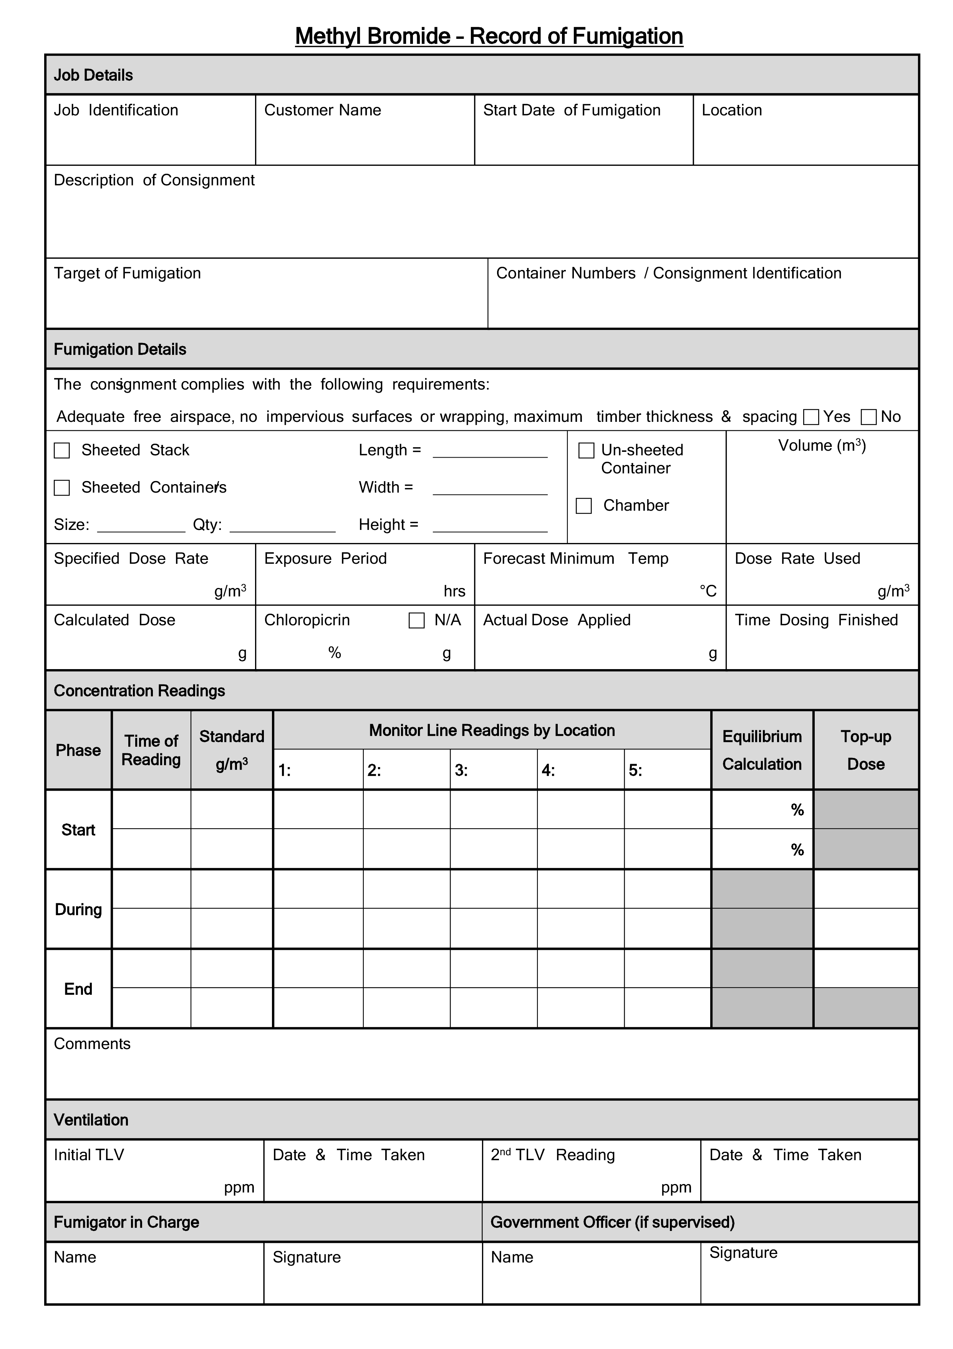

Appendix 2: Example record of fumigation for perishable commodities
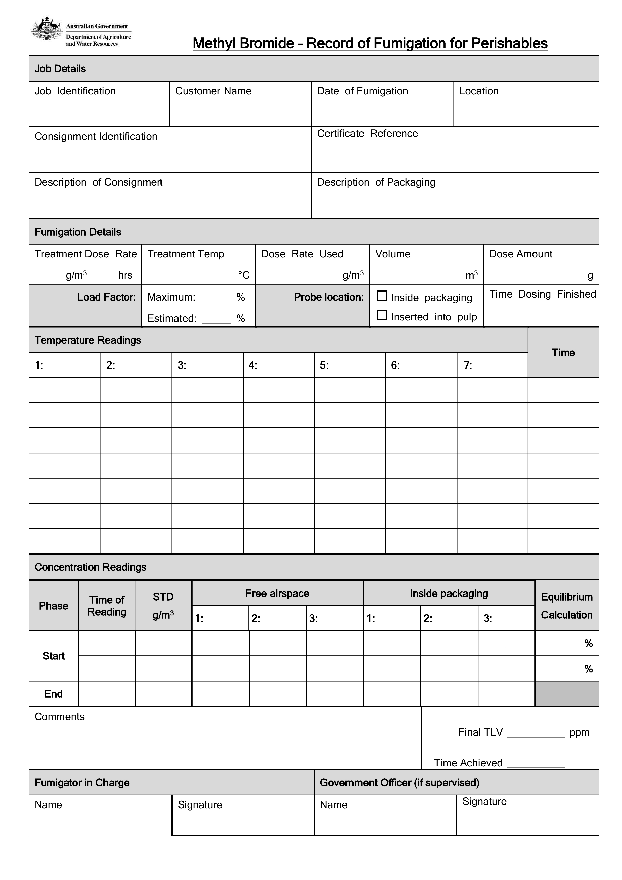

Appendix 3: Example fumigation certificate
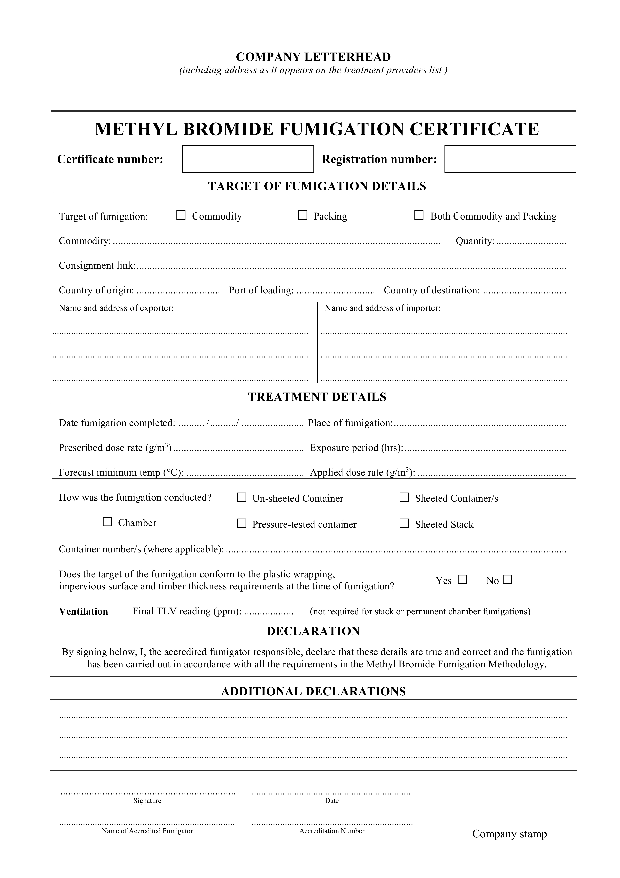

Appendix 4: Methyl bromide monitoring table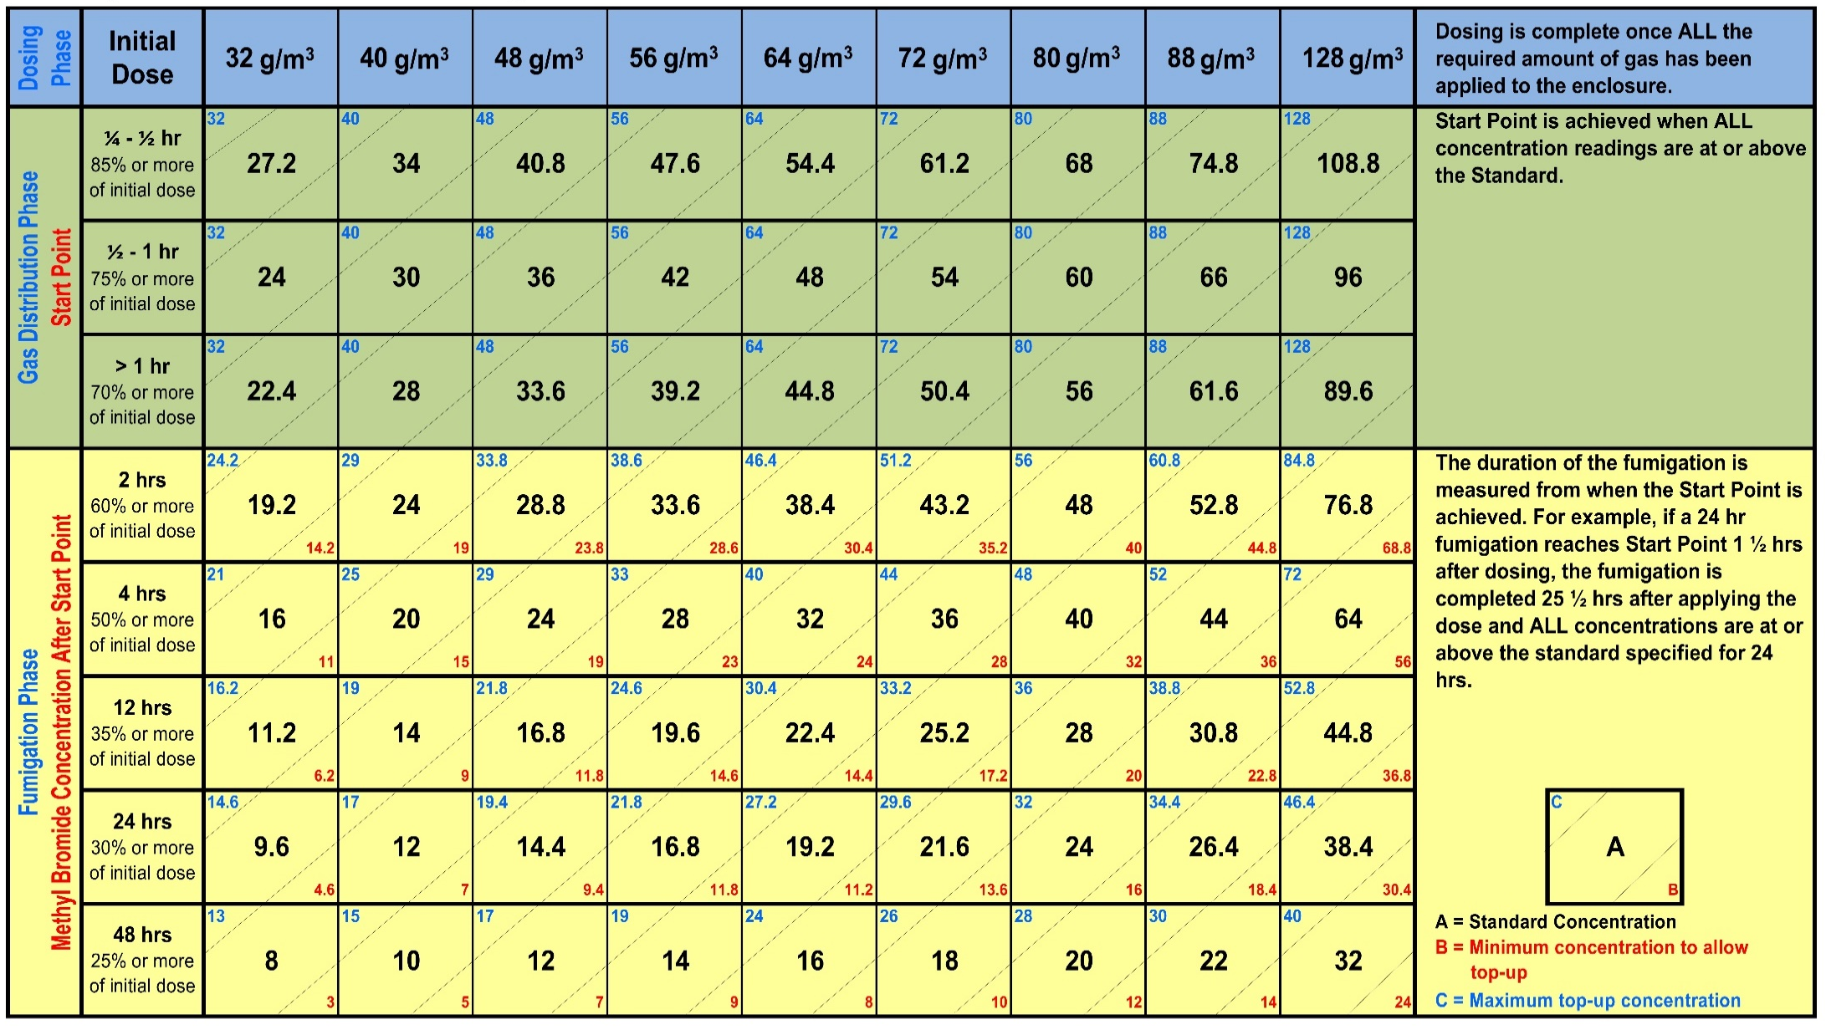

Appendix 5: Concentrations for dose rates and times

Appendix 6: Concentrations for dose rates for fumigations that require 80% retention

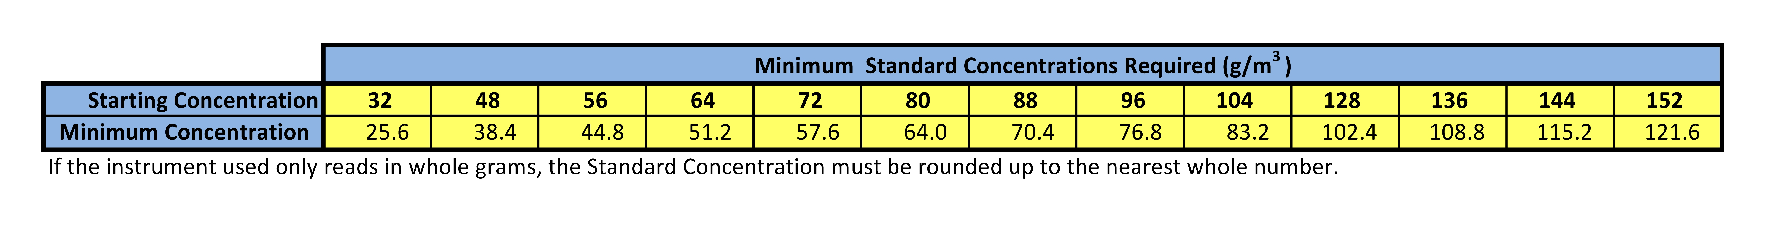

Glossary
Term | Definition
Ambient temperature | The air temperature of the surrounding area where the fumigation will be conducted.
Buffer zone | The area around the enclosure, outside of which, the concentration levels of methyl bromide should not exceed the TLV–TWA during ventilation.
Chloropicrin | A strong-smelling chemical commonly added to the odourless methyl bromide to indicate the presence of gas.
Commodity | The item or goods that are being exported or imported.
Concentration | The amount of fumigant present at a certain point in the fumigation enclosure, usually expressed as grams per cubic metre (g/m³).
Consignment | Refers collectively to the commodity, any packing materials used and the mode of transport such as a shipping container.
Dosage | The cumulative concentration of fumigant in the enclosure over the exposure period. Also referred to as the Concentration by Time Product (CT Product) normally expressed as gram hours per cubic metre.
Dose | The amount of fumigant applied to a fumigation enclosure.
Dose rate | The prescribed concentration of fumigant to be used per unit of volume and the exposure period.
Enclosure | Any gas-tight space intended to contain sufficient concentrations of fumigant for a period of time. Common examples of fumigation enclosures used for QPS fumigations are sealed shipping containers, gas-proof sheets sealed to an impervious floor and purpose-built chambers
Equilibrium | An even distribution of fumigant throughout the enclosure.
Exposure period | The amount of time, in one continuous block, that the consignment must be exposed to sufficient concentration levels of fumigant to be lethal to the targeted pests.
Free air space | Empty space in the enclosure between, above or around a commodity.
Fumigant | A chemical, which at a particular temperature and pressure can exist in a gaseous state in sufficient concentration and for sufficient time to be lethal to insects and other pests
Fumigation sheets | A sheet (or tarpaulin) that is made of material impervious to the fumigant used to create a temporary fumigation enclosure.
ISPM15 | International Standards for Phytosanitary Measures No. 15 – Regulation of wood packaging material in International trade
Load factor | Specifies the maximum volume of space that the commodity can occupy in the enclosure to achieve rapid fumigation circulation. Normally expressed as a percentage (for example, maximum load factor of 50%).
Maximum top-up concentration | The concentration used to calculate the amount of fumigant to be added to the enclosure when topping-up.
Minimum top-up concentration | The absolute minimum concentration below which levels fumigant concentration must not fall at any time during the exposure period.
Pascal (Pa) | The standard international unit for pressure. Standard atmospheric pressure is 101.325 kPa.
Perishable commodities | Commodities such as, cut flowers, fresh fruit, vegetables and nursery stock that will deteriorate rapidly if not stored or transported under suitable conditions.
Permeability | The rate at which a substance (such as methyl bromide) passes through a material (such as a fumigation sheet).
Pest | Any animal, plant or other organism that may pose a threat to the community or the natural environment.
Quarantine pest | A pest of potential economic and/or environmental importance to an area where it is not yet present, or is present but not widely distributed and is being officially controlled.
Quarantine and Pre-shipment (QPS) | 1) ‘Quarantine applications’, with respect to methyl bromide, are treatments to prevent the introduction, establishment and/or spread of quarantine pests (including diseases), or to ensure their official control, where:  a) Official control is that performed by, or authorised by, a national plant, animal or environmental protection or health authority.  b) Quarantine pests are pests of potential importance to the areas endangered thereby and not yet present there, or present but not widely distributed and being officially controlled.  2) ‘Pre-shipment applications’ are those non–quarantine applications applied within 21 days prior to export to meet the official requirements of the importing country or existing official requirements of the exporting country.  This definition is based on the Montreal Protocol which is seeking to phase-out methyl bromide for non-QPS uses by 2015.
Record of fumigation | A document that records the relevant information to demonstrate the fumigation complied with requirements.
Relevant authority | The government department, ministry or agency responsible for animal and plant biosecurity in the importing or exporting country.
Risk area | The area around the enclosure to which access is restricted to personnel wearing personal protective equipment.
Sampling tube | A small diameter tube used to draw a sample of gas/air mixture from within a fumigation enclosure to measure the fumigant concentration.
Sheet fumigation | A process of creating a gas-tight enclosure by covering/enclosing the commodities to be fumigated under a gas-proof sheet.
Shipping container | Standardised transportation units that can be moved from one mode of transport to another without needing to unload the contents.
Sorption/sorptive | A physical and chemical process by which one substance becomes attached to another. De-sorption is the reversal of this process.
Standard concentration | The fumigant concentration below which the fumigation will not be effective unless additional fumigation is added to the enclosure to compensate.
Target of the fumigation | The target of the fumigation may be the commodity, packaging material or both.
Treatment | Application of a set of specified requirements intended to kill pests and diseases that may be associated with a consignment.
Threshold limit value—time-weighted average (TLV–TWA) | TLV–TWA is the maximum concentration of fumigant that a person can be repeatedly exposed to in the workplace without harmful effects. This figure is based on an 8-hour day, 40-hour working week.

